

## Decision Modeler Report

# Vacation Approval

### Published: 12/6/2022

### By: Rune Løvik

Table of Contents

# Vacation Approval

## Decision Requirement Diagram

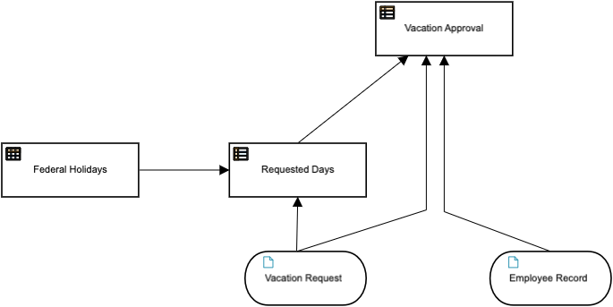

## Elements

#### Vacation Approval (Decision)

**Output Data Type**

|  |  |
| --- | --- |
| Type | tVacationApproval |

**Decision Logic (Decision Table)**

|  |
| --- |
| **Vacation Approval**  *tVacationApproval* |

|  |  |  |  |  |  |
| --- | --- | --- | --- | --- | --- |
| P | Requested Days | Employee Record.AvailableDays | Vacation Approval | | Description |
|  |  |  | Reason | Status |  |
|  | *Number* | *Number* | *Text* | *tStatus*  *"Referred", "Approved", "Rejected"* |  |
| 1 | <=2 | >=2 | "Jepp, du kan dra på ferie" | "Approved" |  |
| 2 | >2 | >=Requested Days | "Sjekk med sjefen først" | "Referred" |  |
| 3 | - | - | "Søknad er avslått du har ikke nok feriedager " | "Rejected" |  |

#### Federal Holidays (Decision)

**Decision Logic (Relation)**

|  |
| --- |
| **Federal Holidays** |

|  |  |
| --- | --- |
| Holiday | Date |
| *Text* | *Date* |
| "Skjærtorsdag" | date("2023-04-06") |
| "Langfredag" | date("2023-04-07") |
| "2 påskedag" | date("2023-04-10") |
| "Offentlig høytidsag" | date("2023-05-01") |
| "Narsjonaldagen" | date("2023-05-17") |
| "Kristi himmelfartsdag" | date("2023-05-18") |
| "2 pinsedag" | date("2023-05-29") |

#### Requested Days (Decision)

**Output Data Type**

|  |  |
| --- | --- |
| Type | Number |

**Decision Logic (Context)**

|  |
| --- |
| **Requested Days**  *Number* |

|  |  |  |  |  |
| --- | --- | --- | --- | --- |
| Raw Days  *Number* | |  | | --- | | (Vacation Request.vacation return - Vacation Request.vacation start)/duration("P1D") | | | |
| Weekend Days  *Number* | |  | | --- | | floor(Raw Days/7)*2 | | | |
| Return earlier weekday  *Number* | |  | | --- | | if Vacation Request.vacation return.weekday>Vacation Request.vacation start.weekday then 0 else 2 | | | |
| Include holidays  *Number* | |  | | --- | | count(Federal Holidays[Date in [Vacation Request.vacation start..Vacation Request.vacation return)]) | | | |
| ((Raw Days - Return earlier weekday) - Weekend Days)-Include holidays | | | |

#### Vacation Request (Input Data)

**Input Data Type**

|  |  |
| --- | --- |
| Type | tVacationRequest |

#### Employee Record (Input Data)

**Input Data Type**

|  |  |
| --- | --- |
| Type | tEmployeeVacationData |

# Hidden Decision Services

#### Approve Vacation Request (Decision Service)

**Elements**

|  |  |  |
| --- | --- | --- |
| **Input** | **Encapsulated Decisions** | **Output Decisions** |
| Vacation Request  *tVacationRequest* |  | Requested Days  *Number* |
| Employee Record  *tEmployeeVacationData* |  | Vacation Approval  *tVacationApproval* |
| Federal Holidays |  |  |

# Data Types

#### tVacationRequest

|  |  |
| --- | --- |
| name |  |
| employeeId |  |
| email |  |
| vacation start |  |
| vacation return |  |
| special reason |  |

#### tEmployeeVacationData

|  |  |
| --- | --- |
| EmployeeName |  |
| Employeeid |  |
| EmployeeEmail |  |
| ManagerName |  |
| ManagerEmail |  |
| AvailableDays |  |

#### tVacationApproval

|  |  |
| --- | --- |
| Reason |  |
| Status | tStatus |

#### tStatus

|  |
| --- |
| *"Referred", "Approved", "Rejected"* |

# Test Cases

#### Test case 1

#### Inputs

**Vacation Request**

**name**

Rune

**employeeId**

1

**email**

rune@dnx.no

**vacation start**

2023-05-01

**vacation return**

2023-05-19

**special reason**

null

**Employee Record**

**EmployeeName**

Rune

**Employeeid**

1

**EmployeeEmail**

rune@dnx.no

**ManagerName**

Bruce

**ManagerEmail**

bruc@google.com

**AvailableDays**

25

#### Outputs

|  |  |  |
| --- | --- | --- |
|  | **Expected** |  |
| **Vacation Approval** | Reason  Supert  Status  null |  |